**VISVESVARAYA TECHNOLOGICAL UNIVERSITY**

**Jnana Sangama, Belagavi - 590018**



**Internship Report on**

**“E-C0MMERCE WEBSITE USING ASP.NET”**

Submitted in partial fulfillment for the award of the degree of

**BACHELOR OF ENGINEERING**

**in**

**ARTIFICIAL INTELLIGENCE AND MACHINE LEARNING**

**By**

**SHARAN SHETTY**

**4MT22AI406**

### Internship Carried out at

**SAARA IT SOLUTIONS PVT.LTD**

|  |  |
| --- | --- |
| **Internal Guide**  **Dr. Archana Nandibewoor**  **Assistant Professor** | **External Guide**  **Mr. Nikhil Karthik**  **Senior Software Developer** |
|  |  |



**DEPARTMENT OF ARTIFICIAL INTELLIGENCE AND MACHINE LEARNING**

# MANGALORE INSTITUTE OF TECHNOLOGY & ENGINEERING

*Accredited by NAAC with A+ Grade, An ISO 9001: 2015 Certified Institution* (*A Unit of Rajalaxmi Education Trust®, Mangalore - 575001*) Affiliated to VTU, Belagavi, Approved by AICTE, New Delhi

Badaga Mijar, Moodabidri-574225, Karnataka

**2024-2025**

# MANGALORE INSTITUTE OF TECHNOLOGY & ENGINEERING

(A Unit of Rajalaxmi Education Trust®, Mangalore)

Autonomous Institute affiliated to VTU, Belagavi, Approved by AICTE, New Delhi Accredited by NAAC with A+ Grade & ISO 9001:2015 Certified Institution

**DEPARTMENT OF ARTIFICIAL INTELLIGENCE AND MACHINE LEARNING**



CERTIFICATE

Certified that the Research/ Industry Internship report submitted by **SHARAN SHETTY**, USN: **4MT22AI406**, a bonafide student of **Mangalore Institute of Technology & Engineering** in partial fulfillment for the award of Bachelor of Engineering in Artificial Intelligence and Machine Learning of the **Visvesvaraya Technological University, Belagavi** during the academic year **2024-2025**. It is certified that all corrections/suggestions indicated for Continuous Internal Evaluation have been incorporated in the report and deposited in the departmental library. The Internship report has been approved as it satisfies the academic requirements in respect of Internship prescribed for the said degree.

|  |  |  |
| --- | --- | --- |
| **Internal Guide** | **HoD** | **Principal** |
| Dr. Archana Nandibewoor | Mr.Sunil Kumar.S | Dr. Prashanth C M |

### External Viva Name of the Examiner Signature with Date

1.

2.

# ACKNOWLEDGEMENT

I would like to express my sincere gratitude to everyone who supported me throughout my internship journey. First and foremost, I am thankful to **Saara It Solutions Pvt Ltd** for providing me with the opportunity to gain valuable industry experience and enhance my practical knowledge. I am deeply grateful to my supervisor, **Mr. Nikhil Karthik** for their continuous guidance, support, and constructive feedback during my internship period. Their mentorship has played a crucial role in shaping my understanding of the professional environment.

I am grateful to my internal guide**, Dr. Archana Nandibewoor**, Assistant Professor, Department of Artificial Intelligence and Machine Learning for her unwavering support, insightful guidance and continuous encouragement throughout the duration of this internship.

I extend my heartfelt thanks to **Mr. Sunil Kumar S**, Head of the Department of Artificial Intelligence and Machine Learning, for his constant support and motivation, and to **Dr. Prashanth C M**, Principal of Mangalore Institute of Technology and Engineering, for creating an environment that fosters learning and growth.

Special, thanks to our chairman, **Mr. Rajesh Chouta** for his encouragement and having given a opportunity to do this internship.

My sincere, thanks to all the teaching and non-teaching staff of Artificial Intelligence and Machine Learning department for their immense encouragement and support throughout the tenure of the seminar.

Finally, I would also like to express our heartfelt thanks to our family, friends and classmates for their moral support and wishes for the successful completion of this internship program.

**SHARAN SHETTY**

**4MT22AI406**

# ABSTRACT

This project presents a comprehensive E-Commerce Web Application developed using ASP.NET MVC 5 and Entity Framework, designed to provide a seamless shopping experience for users and a robust administrative platform for managing products, users, and orders. It showcases a full-stack solution that integrates front-end design, back-end data management, and secure user authentication.

The application features a dynamic product catalog with categories and detailed product views, allowing users to browse, search, and add products to a shopping cart. Registered users can place orders, manage their profiles, and track order history. On the administrative side, the platform provides functionality for product CRUD operations (Create, Read, Update, Delete), category management, and user management.

The system uses Entity Framework for ORM (Object-Relational Mapping), enabling smooth interaction with the database. Security is handled via ASP.NET Identity, allowing for user registration, login, role-based access control (e.g., Admin vs Customer), and password encryption. The application follows the MVC (Model-View-Controller) architectural pattern, promoting separation of concerns and maintainability.

This e-commerce solution is a great example of how modern web development technologies like ASP.NET MVC 5 and Entity Framework can be used to build scalable, maintainable, and user-friendly applications. It serves both as a practical tool for real-world e-commerce needs and as a valuable learning resource for students and developers exploring full-stack .NET web development.

The application implements responsive design principles using Bootstrap, ensuring compatibility across various devices and screen sizes. The user interface is intuitive, enhancing user engagement and simplifying the purchasing process. The codebase is modular and well-structured, allowing for easy customization and future enhancements such as integrating online payment gateways, implementing product reviews and ratings, or enabling email notifications.

# TABLE OF CONTENTS

|  |  |  |  |
| --- | --- | --- | --- |
| **Chapter** |  | **Title** | **Page No.** |
|  |  | ACKNOWLEDGEMENT | i |
|  |  | ABSTRACT | ii |
|  |  | TABLE OF CONTENTS | iii |
|  |  | LIST OF FIGURES | iv |
|  |  | WEEKLY OVERVIEW OF INTERNSHIP ACTIVITIES | vi-viii |
| **Chapter** | **1** | **INTRODUCTION** | 1 - 2 |
|  | 1.1 | Introduction | 1 |
|  | 1.2 | Objectives | 2 |
| **Chapter** | **2** | **ORGANIZATION PROFILE** | **3-5** |
|  | 2.1 | Overview | 3 |
|  | 2.2 | History | 3-4 |
|  | 2.3 | Offices | 4 |
|  | 2.4 | Services | 5 |
| **Chapter** | **3** | **INTERNSHIP ACTIVITIES** | **6-8** |
|  | 3.1 | Department Worked In | 6 |
|  | 3.2 | Detailed Description of Task Performed | 6-7 |
|  | 3.3 | Learning Outcomes from the Assigned Tasks | 8 |
| **Chapter** | **4** | **WORK CARRIED OUT** | **9-18** |
|  | 4.1 | Description of Projects Worked On | 9 |
|  | 4.2 | Objectives of the Projects | 10 |
|  | 4.3 | Working | 10-14 |
|  | 4.4 | Final Goal | 14 |
|  | 4.5 | Screenshots | 14-18 |
| **Chapter** | **5** | **SKILLS DEVELOPED** | **19-21** |
|  | 5.1 | Technical Skills | 19 |
|  | 5.2 | Python Programming Proficiency | 20 |
|  | 5.3 | Data Handling and Managements | 20 |
|  | 5.4 | Software Development Fundamentals | 20 |
|  | 5.5 | Soft Skills | 20-21 |
|  | 5.6 | Communication and Presentation Skills | 21 |
| **Chapter** | **6** | **CONCLUSION** | 22-23 |
|  | 6.1 | Summary of the Experience | 22 |
|  | 6.2 | Future Scope | 23 |
|  |  | **BIBLIOGRAPHY** | 24 |

**LIST OF FIGURES**

|  |  |  |  |
| --- | --- | --- | --- |
| **Figure** | **No.** | **Title** | **Page No.** |
| Figure | 4.1 | The scraped data stored as a separate csv file for each key  words of Humanetics Newsletter project. | 14 |
| Figure | 4.2 | The data scraped for a particular key words in Humanetics  Newsletter projects | 15 |
| Figure | 4.3 | Result of Scope 1: Conversion of Hyper Graph template into Visual Viewer template of Template Generator project | 15 |
| Figure | 4.4 | Result of Scope 3: Visual Viewer Generator of Template  Generator project. | 16 |
| Figure | 4.5 | When user chooses to convert their existing Hyper Graph  template into Visual Viewer template | 16 |
| Figure | 4.6 | Preview and download option | 17 |
| Figure | 4.7 | When user chooses to generate Visual Viewer template | 17 |
| Figure | 4.8 | Preview and download option. | 18 |

**WEEKLY OVERVIEW OF INTERNSHIP ACTIVITIES**

|  |  |  |  |
| --- | --- | --- | --- |
| **1st Week** | **DATE** | **DAY** | **NAME OF THE TOPIC/MODULE COMPLETED** |
| **17-02-2025** | **MONDAY** | The first day provided a comprehensive understanding of the company's vision, products, and technologies, laying a solid foundation for the upcoming days. |
| **18-02-2025** | **TUESDAY** | The setup of Visual Studio and relevant extensions was smooth, enabling a productive development environment. |
| **19-02-2025** | **WEDNESDAY** | The basics of HTML were covered thoroughly, enhancing understanding of webpage structure. |
| **20-02-2025** | **THURSDAY** | Deepened knowledge of HTML with advanced tags and best practices for cleaner code. |
| **21-02-2025** | **FRIDAY** | Learned fundamental CSS concepts, making pages more visually appealing. |

|  |  |  |  |
| --- | --- | --- | --- |
| **2th Week** | **DATE** | **DAY** | **NAME OF THE TOPIC/MODULE COMPLETED** |
| **24-02-2025** | **MONDAY** | Enhanced CSS skills with advanced layout techniques and responsiveness. |
| **25-02-2025** | **TUESDAY** | Gained a solid understanding of basic JavaScript syntax and interaction with HTML. |
| **26-02-2025** | **WEDNESDAY** | Expanded JavaScript knowledge to handle data and control program flow effectivel. |
| **27-02-2025** | **THURSDAY** | Gained expertise in advanced JavaScript topics, enabling dynamic web functionalities. |
| **28-02-2025** | **FRIDAY** | Successfully installed and configured MS SQL Server for database management. |

|  |  |  |  |
| --- | --- | --- | --- |
| **3rd Week** | **DATE** | **DAY** | **NAME OF THE TOPIC/MODULE COMPLETED** |
| **03-03-2025** | **MONDAY** | Learned basic SQL queries and data handling techniques efficiently |
| **04-03-2025** | **TUESDAY** | Mastered complex SQL concepts for efficient data management. |
| **05-03-2025** | **WEDNESDAY** | Leveraged Bootstrap for faster and responsive web development. |
| **06-03-2025** | **THURSDAY** | Gained proficiency in Bootstrap for professional-looking UI. |
| **07-03-2025** | **FRIDAY** | Introduction to C# installing Visual Studio, .NET versions. |

|  |  |  |  |
| --- | --- | --- | --- |
| **4th Week** | **DATE** | **DAY** | **NAME OF THE TOPIC/MODULE COMPLETED** |
| **10-03-2025** | **MONDAY** | Variables and Data Types. Built a temperature converter using variables. |
| **11-03-2025** | **TUESDAY** | Operators and Expressions. Grade classification system using conditions. |
| **12-03-2025** | **WEDNESDAY** | Conditional Statements. Grade classification system using conditions. |
| **13-03-2025** | **THURSDAY** | Loops: Multiplication table generator and number guessing game. |
| **14-03-2025** | **FRIDAY** | Arrays: Student marks analyzer using arrays. |

|  |  |  |  |
| --- | --- | --- | --- |
| **5th Week** | **DATE** | **DAY** | **NAME OF THE TOPIC/MODULE COMPLETED** |
| **17-03-2025** | **MONDAY** | Strings: Word and character counter application. |
| **18-03-2025** | **TUESDAY** | Methods and Functions: Factorial, power, and average calculation. |
| **19-03-2025** | **WEDNESDAY** | OOP - Classes and Objects: Defining classes, constructors, object creation. |
| **20-03-2025** | **THURSDAY** | |  | | --- | |  |  |  | | --- | | Encapsulation and Properties: Access modifiers, getters, setters. | |
| **21-03-2025** | **FRIDAY** | Inheritance: Base and derived classes, constructor chaining. |

|  |  |  |  |
| --- | --- | --- | --- |
| **6th Week** | **DATE** | **DAY** | **NAME OF THE TOPIC/MODULE COMPLETED** |
| **24-03-2025** | **MONDAY** | Shape drawing app using polymorphism, method overriding, and upcasting. |
| **25-03-2025** | **TUESDAY** | |  | | --- | | Payment gateway simulation with abstraction and interfaces. |  |  | | --- | |  | |
| **26-03-2025** | **WEDNESDAY** | |  | | --- | | Contact list using dictionary and recent actions tracker with stack. |  |  | | --- | |  | |
| **27-03-2025** | **THURSDAY** | Developed calculator with custom exception handling. |
| **28-03-2025** | **FRIDAY** | Log writer and file viewer using file handling. |

|  |  |  |  |
| --- | --- | --- | --- |
| **7th Week** | **DATE** | **DAY** | **NAME OF THE TOPIC/MODULE COMPLETED** |
| **31-03-2025** | **MONDAY** | |  | | --- | |  |  |  | | --- | | Event-based temperature alert system using delegates and events. | |
| **01-04-2025** | **TUESDAY** | Student filter and sorter using LINQ queries. |
| **02-04-2025** | **WEDNESDAY** | Scheduling app with due date calculation using DateTime & TimeSpan. |

|  |  |  |  |
| --- | --- | --- | --- |
| **8th Week** | **DATE** | **DAY** | **NAME OF THE TOPIC/MODULE COMPLETED** |
| **07-04-2025** | **MONDAY** | |  | | --- | |  |  |  | | --- | | Explored ASP.NET folder structure and routing in RouteConfig.cs. | |
| **08-04-2025** | **TUESDAY** | Created HomeController and a static Index view. |
| **09-04-2025** | **WEDNESDAY** | Customized _Layout.cshtml and added navbar using Razor |
| **10-04-2025** | **THURSDAY** | Created a model and displayed it in a strongly-typed view. |
| **11-04-2025** | **FRIDAY** | Built a form using GET/POST with validation. |

|  |  |  |  |
| --- | --- | --- | --- |
| **9th Week** | **DATE** | **DAY** | **NAME OF THE TOPIC/MODULE COMPLETED** |
| **14-04-2025** | **MONDAY** | |  | | --- | |  |  |  | | --- | | Displayed task list with detailed view. | |
| **15-04-2025** | **TUESDAY** | Enabled task editing with pre-filled update forms. |
| **16-04-2025** | **WEDNESDAY** | Added delete functionality with confirmation. |
| **17-04-2025** | **THURSDAY** | |  | | --- | | Integrated Entity Framework Code First. |  |  | | --- | |  | |
| **18-04-2025** | **FRIDAY** | |  | | --- | |  |  |  | | --- | | Enabled Code First Migrations and database updates. | |

|  |  |  |  |
| --- | --- | --- | --- |
| **10th Week** | **DATE** | **DAY** | **NAME OF THE TOPIC/MODULE COMPLETED** |
| **21-04-2025** | **MONDAY** | |  | | --- | |  |  |  | | --- | | Added client- and server-side validation using  annotations. | |
| **22-04-2025** | **TUESDAY** | Used Bootstrap for responsive UI design |
| **23-04-2025** | **WEDNESDAY** | Created reusable partial views for forms. |
| **24-04-2025** | **THURSDAY** | Handled global exceptions and built custom error views. |
| **25-04-2025** | **FRIDAY** | |  | | --- | |  |  |  | | --- | | Implemented search and filtering using LINQ. | |

|  |  |  |  |
| --- | --- | --- | --- |
| **11th Week** | **DATE** | **DAY** | **NAME OF THE TOPIC/MODULE COMPLETED** |
| **28-04-2025** | **MONDAY** | |  | | --- | |  |  |  | | --- | | Deployed the application using IIS or Azure. | |
| **29-04-2025** | **TUESDAY** | Final testing, documentation, and reporting completed. |
| **30-04-2025** | **WEDNESDAY** | |  | | --- | |  |  |  | | --- | | Integrated authentication and authorization using ASP.NET Identity and implemented role-based access. | |
| **01-05-2025** | **THURSDAY** | Holiday. |
| **02-05-2025** | **FRIDAY** | |  | | --- | |  |  |  | | --- | | Developed a role-specific dashboard and restricted admin-level features using role-based security filters. | |

|  |  |  |  |
| --- | --- | --- | --- |
| **12th Week** | **DATE** | **DAY** | **NAME OF THE TOPIC/MODULE COMPLETED** |
| **05-05-2025** | **MONDAY** | |  | | --- | |  |  |  | | --- | | Implemented reporting module with export-to-PDF/Excel functionality using iTextSharp and EPPlus. | |
| **06-05-2025** | **TUESDAY** | Created email notification system for registration and task updates using SMTP in ASP.NET. |
| **07-05-2025** | **WEDNESDAY** | |  | | --- | |  |  |  | | --- | | Integrated third-party chart libraries (Chart.js) for dynamic dashboard visualizations. | |
| **08-05-2025** | **THURSDAY** | Refactored codebase for better modularity and applied SOLID principles. |
| **09-05-2025** | **FRIDAY** | |  | | --- | |  |  |  | | --- | | Conducted full-code review and resolved bugs identified through manual testing. | |

|  |  |  |  |
| --- | --- | --- | --- |
| **13th Week** | **DATE** | **DAY** | **NAME OF THE TOPIC/MODULE COMPLETED** |
| **12-05-2025** | **MONDAY** | Performed load testing using JMeter to ensure system handles concurrent users effectively. |
| **13-05-2025** | **TUESDAY** | Integrated logging using NLog and implemented error monitoring dashboard. |
| **14-05-2025** | **WEDNESDAY** | |  | | --- | |  |  |  | | --- | | Set up unit testing with NUnit to validate critical  components and controller logic. | |
| **15-05-2025** | **THURSDAY** | |  | | --- | |  |  |  | | --- | | Created API endpoints for mobile integration and  tested via Postman. | |
| **16-05-2025** | **FRIDAY** | |  | | --- | |  |  |  | | --- | | Developed role-based dynamic menus and restricted navigation controls.. | |

|  |  |  |  |
| --- | --- | --- | --- |
| **14th Week** | **DATE** | **DAY** | **NAME OF THE TOPIC/MODULE COMPLETED** |
| **19-05-2025** | **MONDAY** | Set up version control using Git with GitHub; documented commits and pull requests. |
| **20-05-2025** | **TUESDAY** | |  | | --- | | Conducted internal user testing and gathered UI/UX  feedback. |  |  | | --- | |  | |
| **21-05-2025** | **WEDNESDAY** | |  | | --- | |  |  |  | | --- | | Finalized and uploaded complete source code to  a private GitHub repository. | |
| **22-05-2025** | **THURSDAY** | Prepared project user manual and developer setup guide. |
| **23-05-2025** | **FRIDAY** | |  | | --- | |  |  |  | | --- | | Deployed final version to live server and validated production database connection. | |

|  |  |  |  |
| --- | --- | --- | --- |
| **15th Week** | **DATE** | **DAY** | **NAME OF THE TOPIC/MODULE COMPLETED** |
| **26-05-2025** | **MONDAY** | |  | | --- | |  |  |  |  |  | | --- | --- | --- | | |  | | --- | |  |  |  | | --- | | Final round of deployment testing, confirmed  bug-free and stable version. | | |
| **27-05-2025** | **TUESDAY** | |  | | --- | |  |  |  | | --- | | Internship completion feedback and experience  discussion session with company supervisor. | |

**CHAPTER 1**

# INTRODUCTION

## Introduction

In the modern digital era, online shopping has revolutionized the way consumers purchase products, making e-commerce platforms an essential part of business strategy. This project is a comprehensive E-Commerce Web Application developed using ASP.NET Core MVC, aiming to provide a secure, scalable, and user-friendly solution for both customers and administrators.

The application is built using the Model-View-Controller (MVC) architectural pattern, which promotes a clean separation of concerns and ensures maintainability and extensibility. The backend is powered by Entity Framework Core, allowing efficient interaction with a relational database, and supports features such as code-first migration and LINQ queries for data manipulation.

This e-commerce platform simulates a real-world online store with core functionalities like user registration and login, product browsing, shopping cart management, order processing, and admin product control. The front-end is designed with Bootstrap, offering a responsive and visually appealing user experience across devices.

One of the major highlights of this project is its role-based access control, where regular users can browse and purchase products, while administrators have the ability to manage the product catalog, categories, and user information. This ensures secure and organized handling of different user types.

Overall, this project serves as a practical demonstration of building a fully functional e-commerce application using ASP.NET Core, showcasing skills in web development, database integration, user authentication, and software architecture. It is an ideal foundation for students and developers looking to deepen their understanding of modern web application development with Microsoft technologies.

## Objectives

The primary objective of this internship project, titled **"E-Commerce Web Application using ASP.NET Core MVC,"** was to gain practical, hands-on experience in full-stack web development by working on a real-time solution under the guidance and standards of a professional software development environment. The project was carried out as part of an internship at [**Company Name**], with the goal of understanding and contributing to the development lifecycle of a modern web application.

The specific objectives of this project included:

1. **To understand and apply industry-standard practices** in developing scalable and secure web applications using the ASP.NET Core MVC framework and C# programming language.
2. **To design and implement an e-commerce platform** that supports essential features such as user registration, product listing, shopping cart functionality, and order management.
3. **To integrate a SQL Server database** using Entity Framework Core for handling dynamic data related to users, products, orders, and transactions.
4. **To implement role-based access control** for differentiating between normal users and administrators, ensuring secure access to various modules and features of the application.
5. **To create a responsive and visually appealing user interface** using Razor Views and Bootstrap, focusing on a seamless user experience across devices.
6. **To work collaboratively with mentors and developers**, gaining insights into real-world project workflows, version control using Git, and debugging and deployment processes.
7. **To demonstrate the ability to independently manage tasks**, understand client requirements, and deliver a functioning application within a stipulated timeline under professional guidance.

This project not only fulfilled the learning objectives set for the internship but also resulted in the development of a functional and reusable e-commerce application that aligns with modern software development standards. It served as a valuable opportunity to bridge academic knowledge with practical implementation in a corporate environment.

**CHAPTER 2**

# ORGANIZATION PROFILE

## Overview

Saara IT Solutions Pvt. Ltd., established in 2006, is a forward-thinking software development company that specializes in providing customized IT solutions to small and medium-sized enterprises. With a mission to enhance business efficiency and a vision to lead in business management software, Saara focuses on inventory management, accounting systems, and real-time business operations.

## History

Founded in **early 2006**, **Saara IT Solutions Pvt. Ltd.** emerged with a vision to revolutionize business operations through intelligent, adaptable, and customized software solutions. Headquartered in India, the company was established to address the growing demand for automation and digital transformation among small and medium-sized enterprises (SMEs). Over the years, Saara IT Solutions has evolved into a trusted name in the IT industry, recognized for its deep domain expertise, innovative product development, and client-centric approach.

With nearly two decades of experience, the company has built a solid reputation for enhancing business models by diagnosing existing challenges, analyzing operational workflows, and implementing technology solutions that increase productivity, efficiency, and profitability.

## Offices

To Saara IT Solutions primarily operates from India, the company is actively expanding its footprint globally through remote services, digital platforms, and strategic partnerships. Their main development center is equipped with a skilled team of IT professionals committed to delivering excellence.

## Services

Saara IT Solutions offers a wide range of **IT services**, with a strong emphasis on delivering personalized and affordable solutions. Their **core services** include:

* **IT Consulting**  
  Strategic guidance to identify and implement the right technology to meet business goals.
* **Custom Software Development**  
  Tailor-made software applications, primarily in inventory control, accounting, and enterprise management.
* **Product Support and Maintenance**  
  Ongoing support services to ensure software remains up-to-date and aligned with evolving business requirements.
* **Software Implementation and Integration**  
  Seamless deployment and integration of new solutions with existing systems to optimize operations.
* **Cloud-Based Solutions**  
  Scalable cloud applications for real-time business management and data access.

**CHAPTER 3**

# INTERNSHIP ACTIVITES

## Department Worked In

During my internship at Saara IT Solutions Pvt. Ltd., I was assigned to the Web Application Development Department, which is dedicated to designing and delivering modern, scalable, and user-friendly web applications. The department primarily uses technologies such as ASP.NET MVC, C#, HTML, and CSS to build solutions that cater to clients across industries. My role focused on developing and maintaining modules for internal systems and client-facing portals, giving me firsthand exposure to software lifecycle activities including design, development, testing, and deployment using Microsoft’s technology stack.

## Detailed Description of Task Performed

Throughout the internship, I worked on two key modules centered around user and task management systems within a broader ASP.NET-based enterprise solution:

1. **User Interface Design**
   * Designed and structured responsive webpages using HTML5, CSS3, and Bootstrap.
   * Developed master layout (_Layout.cshtml) and navigation bar to maintain consistent look across all views.
2. **Product Management Module (Admin Panel)**
   * Created functionality to Add, Edit, Delete, and List Products using ASP.NET MVC controllers and Razor views.
   * Integrated image upload and file storage for product thumbnails.
   * Developed dropdowns for category and subcategory selection using dynamic ViewBag and LINQ queries.
3. **User Registration & Authentication**
   * Implemented user login and registration using ASP.NET Identity.
   * Enabled role-based access control for Admin and Customer users.
   * Developed session management and logout functionality.
4. **Shopping Cart and Checkout Process**
   * Created a dynamic shopping cart using TempData and Session.
   * Allowed users to add, remove, and update product quantities in the cart.
   * Built checkout and order summary pages, and stored order details in the database.
5. **Database Design and Integration**
   * Designed relational tables in SQL Server for Products, Orders, Users, and Categories.
   * Used Entity Framework Code First to map models to the database and manage migrations.
   * Wrote custom LINQ queries for filtering, searching, and sorting products.
6. **Order Management (Admin Panel)**
   * Displayed all order records to the admin with options to filter by date and user.

## 3.4 Learning Outcomes from the Assigned Tasks

This project provided in-depth exposure to full-stack ASP.NET MVC development in the context of a real-world e-commerce platform. It helped bridge the gap between academic learning and practical implementation.

**Key Learning Outcomes:**

* Gained proficiency in ASP.NET MVC, including Controllers, Views, Models, and Routing.
* Improved C# programming skills by writing modular, reusable code.
* Strengthened knowledge of front-end development using HTML, CSS, and Bootstrap for responsive UIs.
* Learned Entity Framework for database operations and code-first migrations.
* Understood user authentication, session management, and security in web applications.
* Built familiarity with role-based access control and dashboard management.
* Developed a good understanding of e-commerce flows—product listings, cart management, and order processing.

**CHAPTER 4**

# WORK CARRIED OUT

## Description of Projects Worked On

During my internship at Saara IT Solutions Pvt. Ltd., I worked on a core development project titled “E-Commerce Website using ASP.NET MVC Framework”. This project aimed to deliver a fully functional online shopping platform that supports user authentication, product browsing, shopping cart features, and administrative product management.

The project was divided into two primary modules:

1. Customer-Facing Module:
   * Designed a user-friendly web interface for product browsing, category filtering, adding to cart, and placing orders.
   * Users could register, log in securely, and manage their shopping cart and order history.
   * Emphasized responsive design using HTML5, CSS3, and Bootstrap.
2. Admin Panel Module:
   * Built a secure admin dashboard for managing product listings, inventory, categories, and order records.
   * Implemented features for CRUD (Create, Read, Update, Delete) operations using ASP.NET MVC with C# and Entity Framework.

This work also included configuring database tables using SQL Server and performing data transactions via LINQ queries and Code First Migrations.

## Objectives of the Projects

## The main objectives of the E-Commerce Website project were:

## To design and develop a responsive, full-stack e-commerce website using ASP.NET MVC.

## To implement secure user authentication and role-based access control.

## To allow users to browse, search, and order products efficiently.

## To empower admins with a backend system to manage products, orders, and customer data.

## To integrate a SQL Server database using Entity Framework Code First Approach.

## To deploy and test the application on a local IIS server for final validation.

## Working

## Frontend Development:

## Used Razor View Engine to design views for user interface components like Home Page, Product Listings, Product Details, and Shopping Cart.

## Employed Bootstrap for responsive layout and CSS for styling.

## Created reusable layout templates like _Layout.cshtml and partial views for forms and headers.

## User Authentication & Authorization:

## Implemented user registration and login with ASP.NET Identity.

## Applied role-based authorization, separating admin users from regular customers.

## Secure session management and logout were configured to enhance user experience and safety.

## Database Design and Integration:

## Built models for Products, Orders, Users, and Categories.

## Configured Entity Framework DbContext to manage migrations and database tables.

## Used LINQ queries to fetch and manipulate data efficiently.

## Admin Module:

## Developed an admin dashboard that allows:

## Adding and removing products.

## Updating product price, stock, and details.

## Viewing all orders placed by customers.

## Customer Module:

## Customers could browse products by category or search by keyword.

## Shopping cart handled via Session variables, with options to increase or decrease item quantities.

## Checkout included a confirmation page, order summary, and invoice generation.

## Orders were stored in SQL Server and linked to the respective user.

## Testing and Validation:

## Validated forms using both client-side (JavaScript) and server-side (Data Annotations).

## Conducted end-to-end testing of the entire ordering process.

## Deployment:

## Deployed the application using IIS (Internet Information Services) on a local Windows server.

## Verified deployment success and database connection integrity.

## Final Goal:

* The final goal of this project was to build a complete and functional e-commerce platform that could demonstrate:
* A real-world shopping experience for users.
* A fully manageable backend for administrators.
* Secure login and user role management.
* Full integration of ASP.NET MVC with SQL Server and Entity Framework.
* Responsiveness and mobile compatibility using Bootstrap.
* A successful end-to-end software development cycle, from design to deployment.

This project gave me a comprehensive understanding of how large-scale ASP.NET MVC applications are developed, secured, and maintained in real-world business scenarios.

## Screenshots

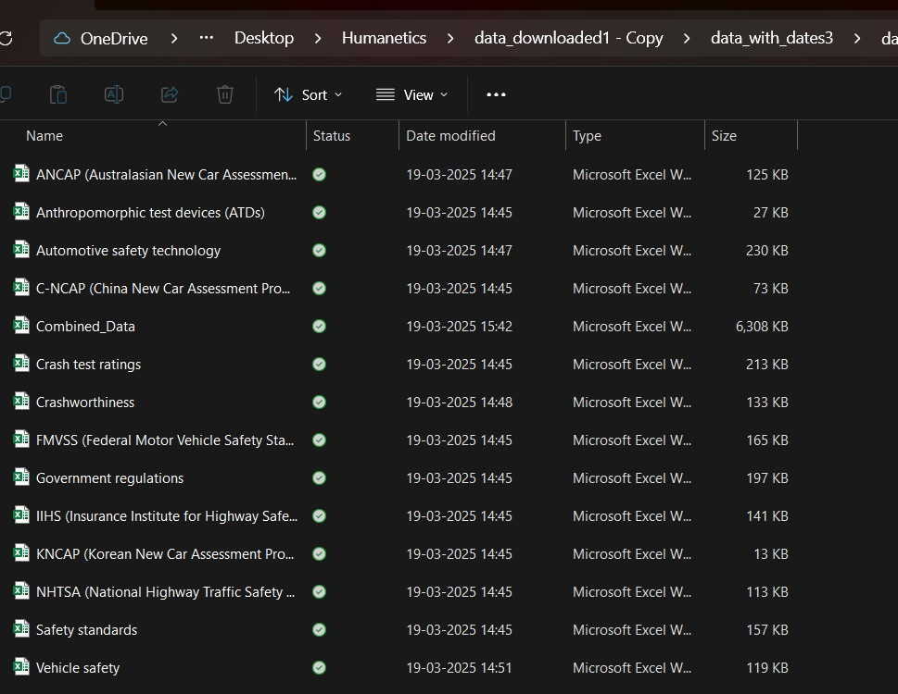

**Figure 4.1 The scraped data stored as a separate csv file for each key words of Humanetics Newsletter project.**

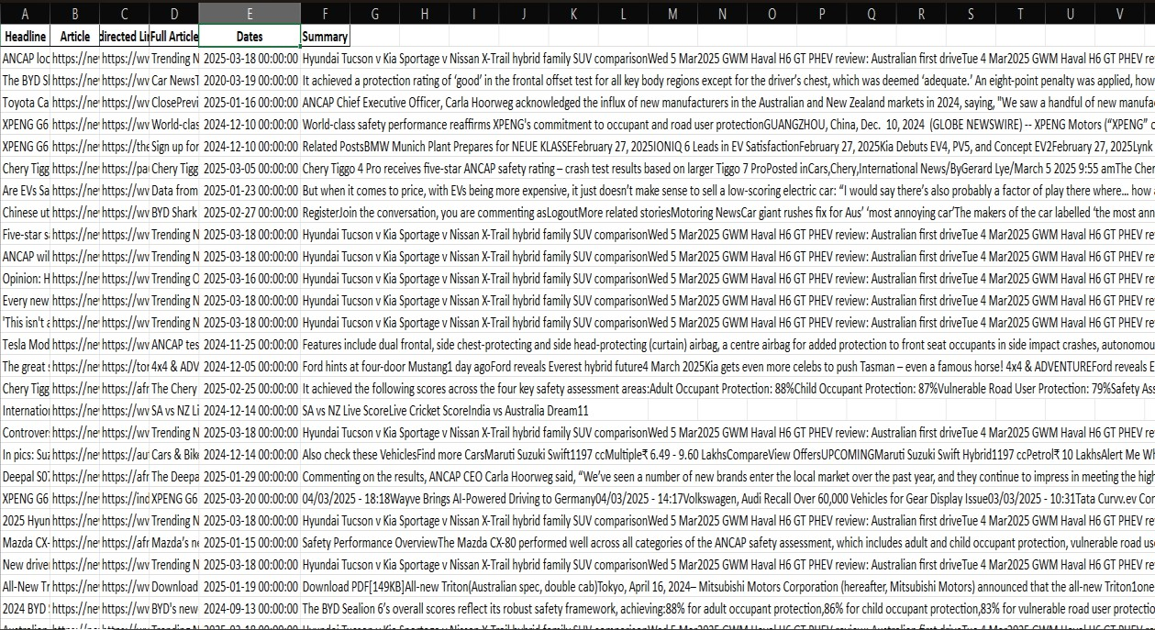

**Figure 4.2 The data scraped for a particular key words in Humanetics Newsletter projects**

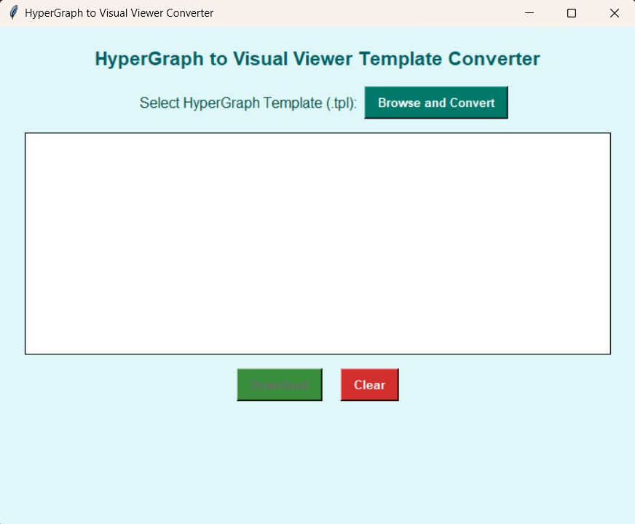

**Figure 4.3 Result of Scope 1: Conversion of Hyper Graph template into Visual Viewer template of Template Generator project.**

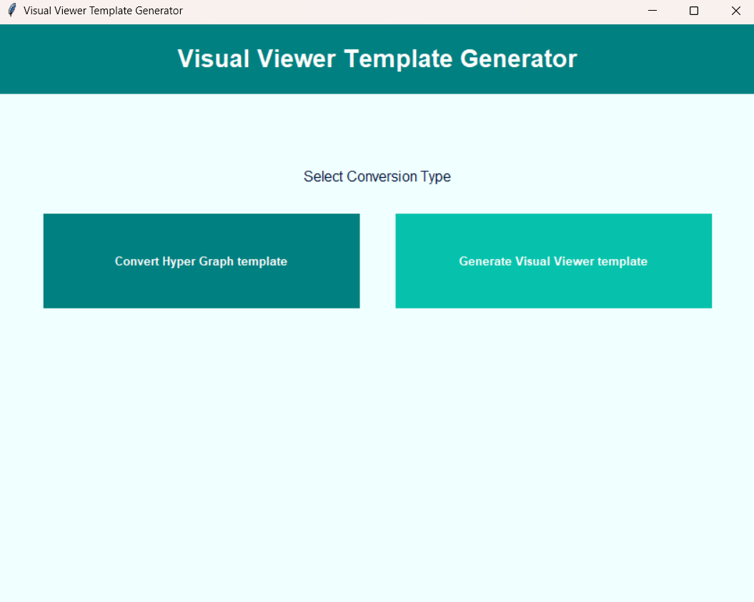

**Figure 4.4 Result of Scope 3: Visual Viewer Generator of Template Generator project.**

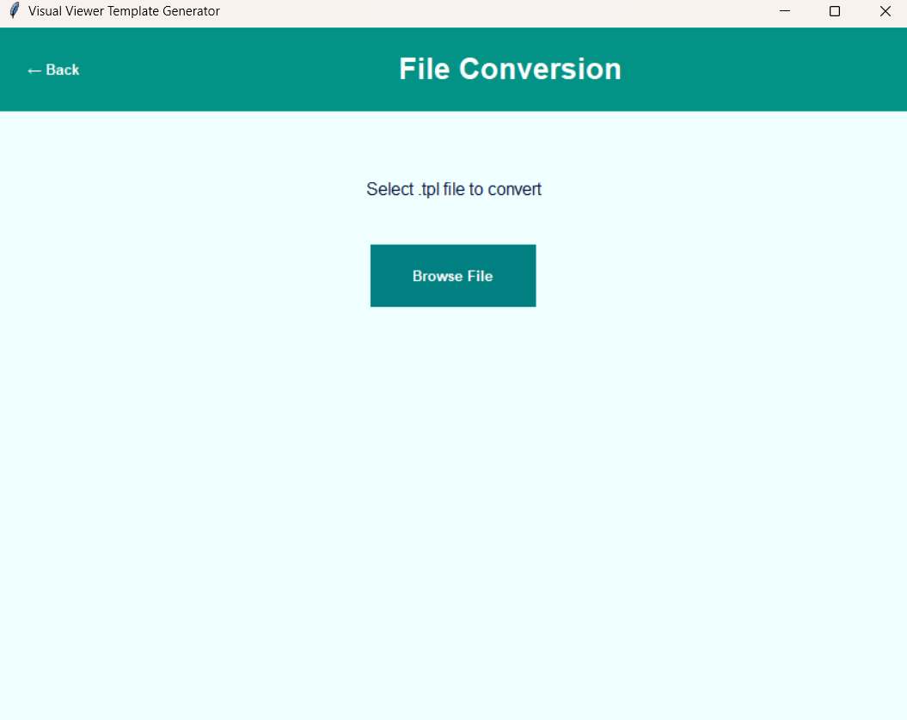

**Figure 4.5 When user chooses to convert their existing Hyper Graph template into Visual Viewer template**

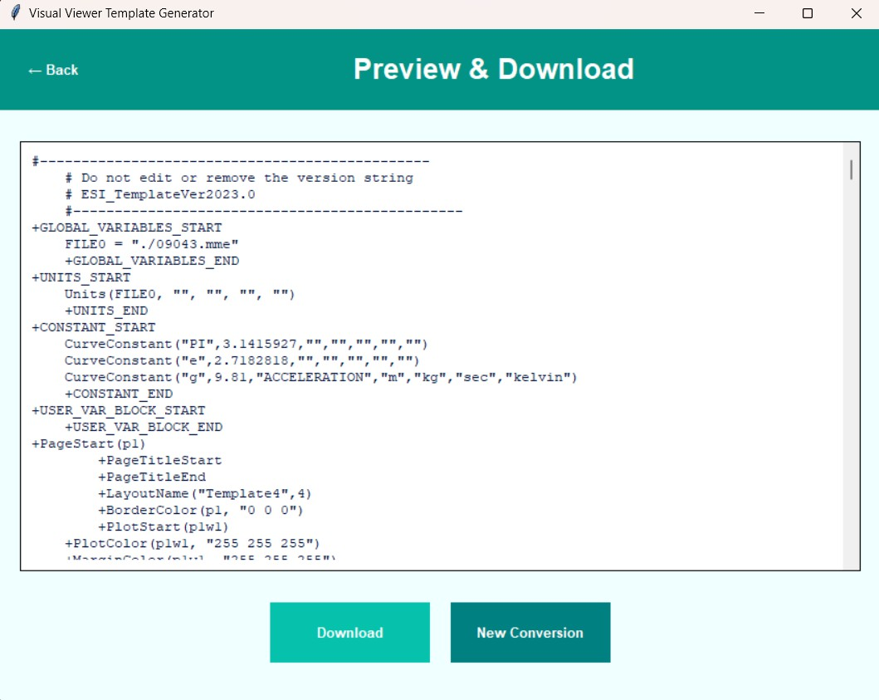

**Figure 4.6 Preview and download option.**

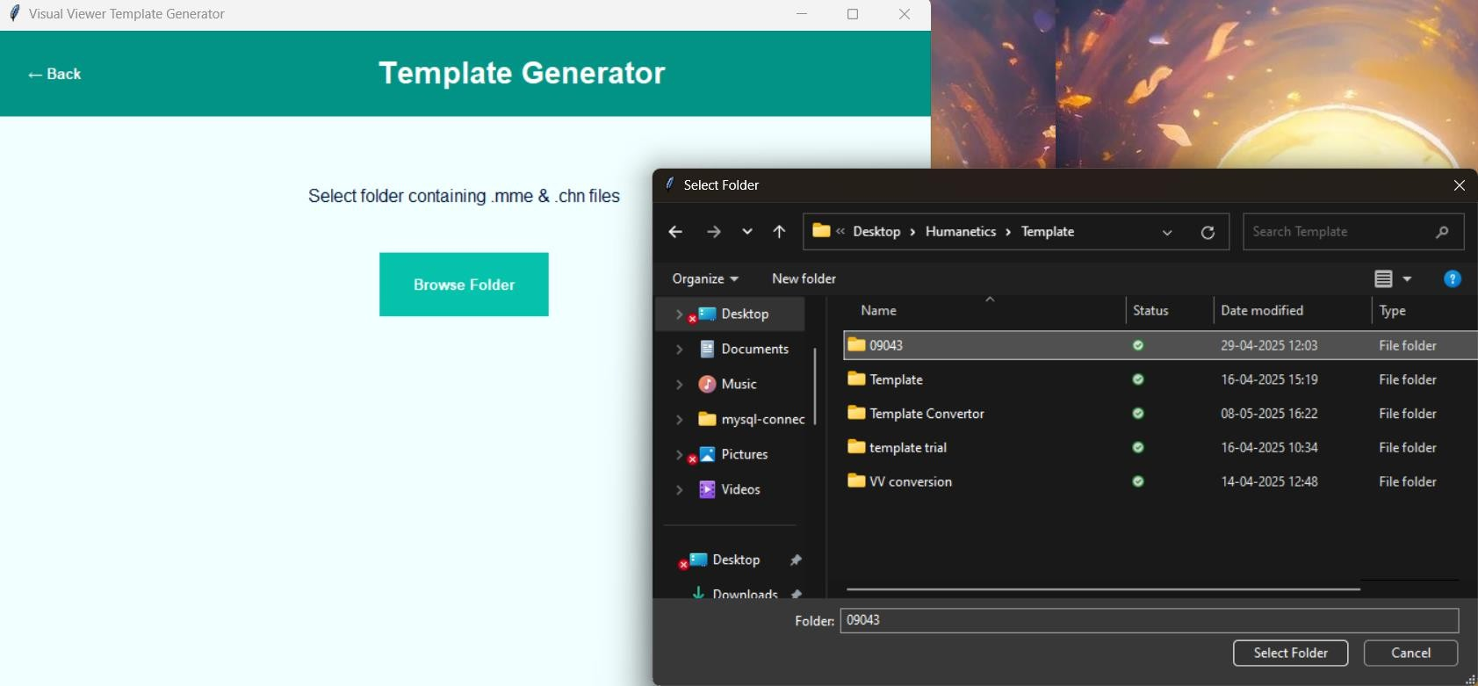

**Figure 4.7 When user chooses to generate Visual Viewer template**

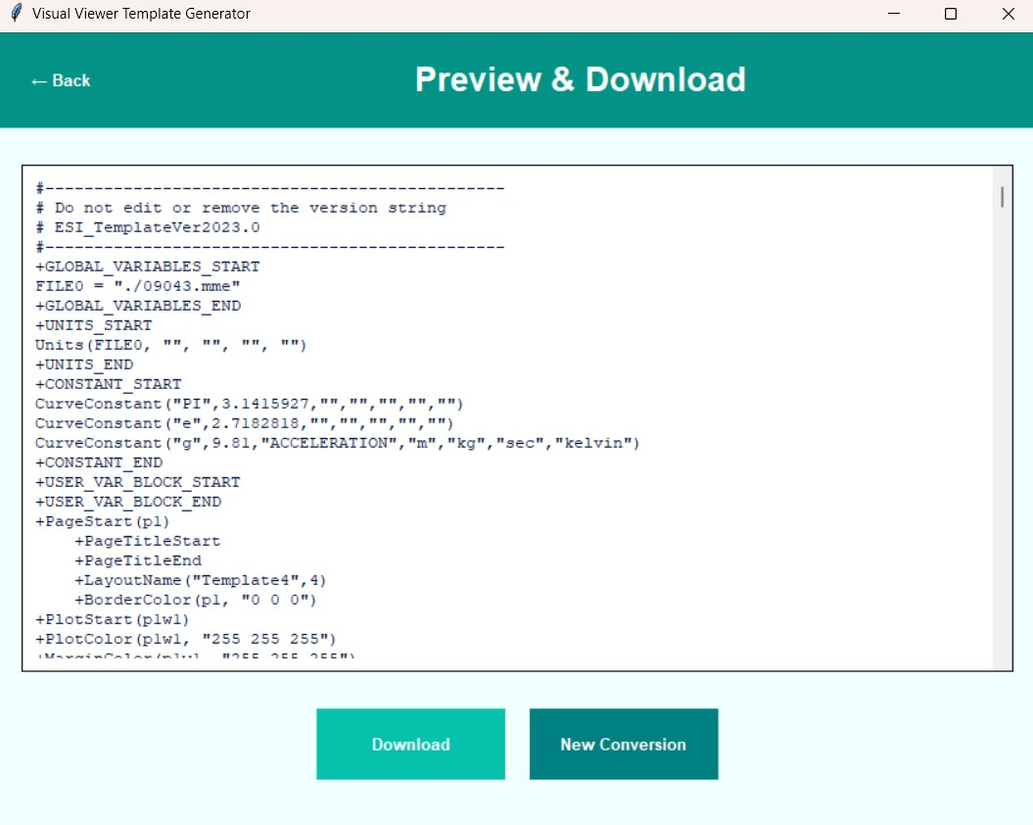

**Figure 4.8 Preview and download option.**

**CHAPTER 5**

# SKILLS DEVELOPED

My internship at Saara IT Solutions Pvt. Ltd. provided me with a diverse and comprehensive set of technical and soft skills. Through the design, development, and deployment of a functional E-Commerce Web Application using ASP.NET MVC, I gained hands-on experience with real-world software development methodologies and strengthened my programming and problem-solving abilities.

## Technical Skills:

**ASP.NET MVC Framework:**

* Gained in-depth knowledge of building modular web applications using the Model-View-Controller architecture.
* Developed and structured multiple views, models, and controllers to implement business logic and render dynamic content.

**Front-End Technologies (HTML, CSS, Bootstrap):**

* Designed responsive and interactive user interfaces using HTML5, CSS3, and Bootstrap.
* Customized views using Razor syntax, partial views, and layout pages in Layout.cshtml.

**Database Management with SQL Server:**

* Implemented Code First Migrations using Entity Framework to design and manage the database schema.
* Used LINQ for efficient data querying and manipulation across models like Products, Orders, Users, and Categories.

**User Authentication and Role-Based Authorization:**

* Integrated ASP.NET Identity for secure login/logout mechanisms.
* Assigned roles to differentiate admin users from customers, ensuring feature access control.

**CRUD Operations and MVC Routing:**

* Developed full CRUD functionality for product listings, cart operations, and order management.
* Customized routes and implemented controller actions to handle GET and POST requests efficiently.

## C# Programming Proficiency

## Strengthened core C# programming skills through implementation of backend logic, model classes, and server-side validation.

## Worked with interfaces, classes, and error handling mechanisms to build a reliable application backend.

## Gained hands-on experience with delegates, LINQ queries, and reusable methods for common functionalities.

## Data Handling and Management:

* Proficiently managed form data, query parameters, and model binding between views and controllers.
* Validated input on both client-side (using Bootstrap classes) and server-side (using Data Annotations) to maintain data integrity.
* Handled dynamic data with ViewBag, TempData, and Session variables to enhance the user experience.

## Software Development Fundamentals:

* Followed MVC architecture principles, ensuring separation of concerns and scalability.
* Practiced code modularization for easier debugging, maintenance, and version control.
* Gained familiarity with Visual Studio IDE, Git for versioning, and IIS for local deployment.

## Soft Skills:

**Problem Solving & Analytical Thinking:**

* Resolved application issues such as route conflicts, validation errors, and deployment bugs by debugging and analyzing logs.
* Created efficient solutions to implement shopping cart logic and user-specific product filters.

**Project Planning & Task Execution**:

* Managed time effectively while planning daily sprints and module integration timelines.
* Applied test-driven logic to validate user registration, cart management, and checkout workflows.

**Attention to Detail:**

* Ensured that product pages were fully responsive and error-free.
* Verified database connections and ensured correct mapping between entity classes and SQL tables.

## Communication and Presentation Skills:

Prepared and presented project progress reports and functional demos to mentors and supervisors.

Created user manuals and documentation explaining system functionality for both admin and customer modules.

Communicated technical approaches clearly with team members, demonstrating the ability to collaborate effectively.

**CHAPTER 6**

# CONCLUSION

## Summary of the Experience

My internship at Saara IT Solutions Pvt. Ltd. was a transformative learning experience that allowed me to apply theoretical knowledge to real-world scenarios. Working in the Software Development Department, I was entrusted with the development of a fully functional E-Commerce web application using ASP.NET MVC, which covered essential aspects such as product management, user authentication, order processing, and payment simulation.

Through hands-on tasks like creating user interfaces with HTML/CSS and Bootstrap, managing data with Entity Framework and SQL Server, and implementing role-based security and CRUD operations using C#, I gained a solid foundation in full-stack .NET web development. Collaborating with a team of professionals and participating in project reviews also honed my communication, documentation, and debugging skills.

Beyond technical growth, the internship helped develop my confidence, professionalism, and problem-solving mindset. It offered an ideal environment for exploring cutting-edge tools, improving code quality, and understanding how software products are built, tested, and deployed in a live business context.

## Future Scope

The knowledge and experience gained during this internship have laid a strong groundwork for my future career as a software developer. Moving forward, I plan to:

* **Deepen my understanding of ASP.NET Core** and explore Microservices architecture to build more scalable web applications.
* **Expand my knowledge in frontend frameworks** such as React or Angular to complement my backend skills.
* **Contribute to open-source ASP.NET projects** to gain community exposure and collaborative experience.
* **Explore DevOps practices** including CI/CD pipelines and cloud hosting platforms like Azure to enhance deployment and maintenance capabilities.

# BIBLIOGRAPHY

1. <https://learn.microsoft.com/en-us/aspnet/mvc/overview/>
2. <https://learn.microsoft.com/en-us/ef/core/>
3. https://getbootstrap.com/docs/5.3/getting-started/introduction/
4. https://www.w3schools.com/cs/
5. https://www.w3schools.com/html/
6. https://www.w3schools.com/css/
7. <https://developer.mozilla.org/en-US/docs/Web/JavaScript/Guide>
8. <https://learn.microsoft.com/en-us/aspnet/identity/overview/>
9. https://www.geeksforgeeks.org/ecommerce-website-project-in-asp-net-mvc/
10. <https://learn.microsoft.com/en-us/sql/sql-server/?view=sql-server-ver16>